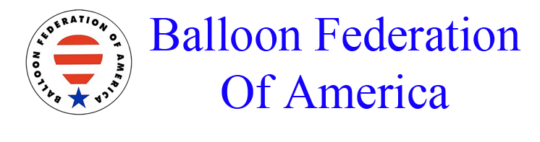


June 9, 2024

2024 US National PZ altitude list

Almost all of the red PZ’s have a top altitude of 900 feet MSL however there are three (3) red PZ’s that have a top altitude of 1,400 MSL.
Those red PZ’s are: 2201, 4296 & 4297.

Sam Parks
Championship Director

